|  |
| --- |
| 21.February.2019 |

|  |
| --- |
| Documentation for CodeReview06 |

# Goals

* + - Create a Homepage using Typescript and style it with bootstrap.
      * Make a Parent class which holds the general information (properties).
      * Extend the Parent class and create three child classes with specific information.
      * Group the child classes into separate rows.
      * Add date/time to the separate locations and display them sorted in an array of locations (places,events,restaurants) ascending based on the created date/time property.
      * Make the homepage responsive to different screen sizes for example:

(small screen, medium screen, large screen)

## Non-Goals

* + - * In this project we don’t expect:

to rate the locations.

to have a user interface.

to store the data of the users.

## Anti-Goals

* + - Not allowed to leave comments for users.
    - Allowing unauthorized access to sensitive data.

Use-Case-Diagram

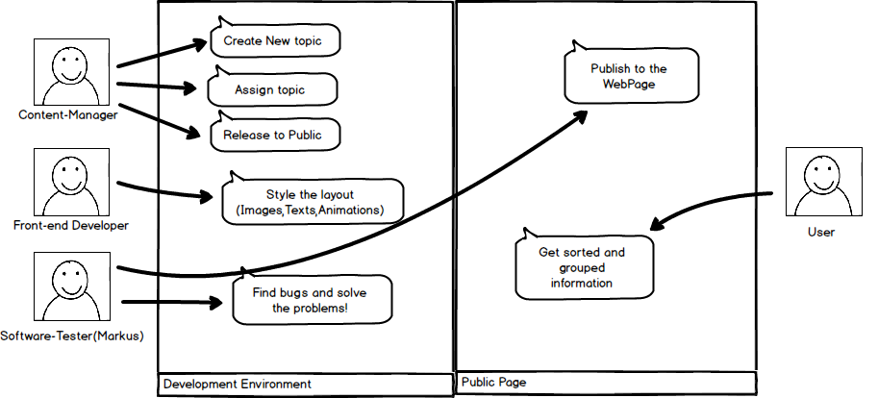

Mockup

